**Handheld LCR Meters(uncategorized)**

<https://www.alibaba.com/product-detail/Handheld-LCR-Meter-Capacitance-Inductance-Resistance_1600500056391.html?spm=a2700.galleryofferlist.normal_offer.d_title.2dbc32dbSRkBlC>

**Prices:** 1 to 19 pieces US$259.00

20 to 49 pieces US$239.00

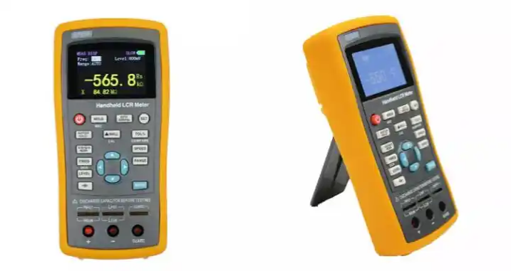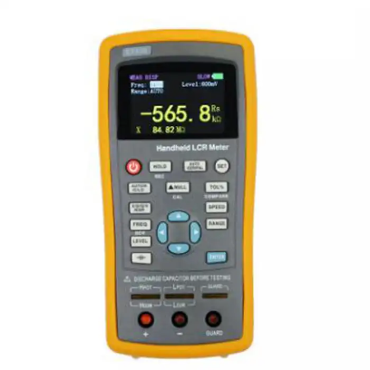>= 50 pieces US$219.00

**Product Name:** GAOTek LCR Digital Bridge Meter

**Product ID:** GAOTek-HLM-201

**Overview:** GAOTek LCR Digital Bridge Meter sets 2.8inch TFT display, flexible and convenient button operation and full speed USB communication in one; large capacity lithium battery can ensure long-term work. Functionally, it has not only comprehensive measurement parameters, but also deviation measurement and screening. The output frequency can be continuously adjusted. In terms of performance, the basic accuracy is up to 0.2%.

**Features:**

* The highest measuring frequency is 100 kHz, and the stepping frequency is continuously adjustable at 1Hz
* Supporting DC Resistance and Electrolytic Capacitance Measurement
* Internal bias voltage output (10mV- to 500mV)
* Automatic Recognition of Component Measurement
* Support screening and deviation measurement
* 2.8inch TFT display, 4-bit semi-display
* USB communication interface
* Large capacity lithium battery power supply
* Support SCPI protocol
* Provide system settings, can configure language, buzzer, screen brightness and so on according to their own requirements
* The basic measurement accuracy is 0.3%
* Adjustable measuring speed, manual and automatic range
* Short circuit correction with open circuit
* Provide multiple test ports

**Technical Specifications:**

|  |  |
| --- | --- |
| **Best frequency** | 100 Hz,120 Hz,1 KHz,10 KHz, 40 KHz, 100 KHz |
| **Basic accuracy** | 0.20% |
| **Display** | 2.8inch TFT LCD |
| **Display digit** | Main parameters: 5 bits, secondary parameters: 5 bits |
| **Measurement parameters** | Main parameters: L/C/R/Z, sub-parameters: X/D/Q/theta/ESR |
| **Electrolytic capacitor mode** | √ |
| **DCR mode** | √ |
| **measuring range** | L:0.000μH to 2000H,C:0.000pF to 20.000mF,R:0.0001Ω to 200.00MΩ |
| **Measurement display speed** | 1/s (slow), 2/s (medium), 4/s (fast) |
| **Internal offset** | 0 mV to 500 mV adjustable, 1 mV step |
| **Test level** | 0.1 Vrms, 0.3 Vrms, 0.6 Vrms, 1 Vrms |
| **Calibration function** | Open circuit calibration and short circuit calibration |
| **Screening function** | The limit range of screening can be set to 1%-50%, of which the fixed points are 1%, 5%, 10%, 20%. |
| **Deviation measurement** | Used to compare the percentage of deviation between the component and the nominal value set and display |
| **Other** | Adjust backlight brightness, automatic shutdown time can be set, Chinese and English optional, USB Device communication |

<https://cathy92722.en.made-in-china.com/product/oTkplIudhJce/China-100kHz-Handheld-Digital-Lcr-Meter-Portable-Handheld-Inductance-Capacitance-Resistance-Measuring-Meter.html>

**Price:** 1 Piece US$125.00

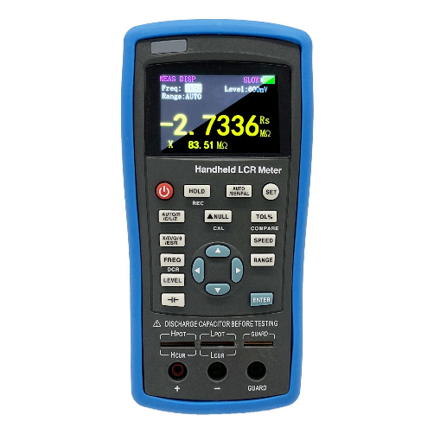

**Product Name:** GAOTek Handheld Digital Lcr Meter

**Product ID:** GAOTek-HLM-202

**Overview:** sets GAOTek Handheld Digital Lcr Meter 2.8inch TFT display, flexible and convenient button operation and full speed USB communication in one; large capacity lithium battery can ensure long-term work. Functionally, it has not only comprehensive measurement parameters, but also deviation measurement and screening. The output frequency can be continuously adjusted. In terms of performance, the basic accuracy is up to 0.2%.

**Features:**

* The highest measuring frequency is 100kHz, and the stepping frequency is continuously adjustable at 1Hz
* Supporting DC Resistance and Electrolytic Capacitance Measurement
* Internal bias voltage output (10 mV to 500 tmV)
* Automatic Recognition of Component Measurement
* Support screening and deviation measurement
* 2.8-inch TFT display, 4-bit semi-display
* USB communication interface
* Large capacity lithium battery power supply
* Support SCPI protocol
* Provide system settings, can configure language, buzzer, screen brightness and so on according to their own requirements
* The basic measurement accuracy is 0.2%
* Adjustable measuring speed, manual and automatic range
* Short circuit correction with open circuit
* Provide multiple test ports

**Technical Specifications:**

|  |  |
| --- | --- |
| **Test frequency** | 100 Hz to 100 KHz Continuously adjustable 1 Hz stepping |
| **Basic accuracy** | 0.20% |
| **Display** | 2.8inch TFT LCD |
| **Display digit** | Main parameters: 5 bits, secondary parameters: 5 bits |
| **Measurement parameters** | Main parameters: L/C/R/Z, sub-parameters: X/D/Q/theta/ESR |
| **Electrolytic capacitor mode** | √ |
| **DCR mode** | √ |
| **measuring range** | L:0.000 μH to 2000 H,C:0.000 pF to 20.000 mF,R:0.0001 Ω to 200.00 MΩ |
| **Measurement display speed** | 1/s (slow), 2/s (medium), 4/s (fast) |
| **Internal offset** | 0 mV to 500 mV adjustable, 1 mV step. |
| **Test level** | 0.1 Vrms or 0.3 Vrms or 0.6 Vrms |
| **Calibration function** | Open circuit calibration and short circuit calibration |
| **Screening function** | The limit range of screening can be set to 1%-50%, of which the fixed points are 1%, 5%, 10%, 20%. |
| **Deviation measurement** | Used to compare the percentage of deviation between the component and the nominal value set and display |
| **Other** | Adjust backlight brightness, automatic shutdown time can be set, Chinese and English optional, USB Device communication |